**Tiffany Thornton Finds New Love after Tragic Death of Husband**



Tiffany Dawn Thornton is a young lady that is destined to go places and is already going places. She is an American actress, singer and radio presenter, born February 14, 1986 in Texas. She is best known for playing a co-starring role as Tawni Hart in *Sonny with a Chance, a* series on the Disney Channel Original Series, *Sonny with a Chance* (2009). She is also known for her parts in *Hatching Pete* (2009) and *The Dog Who Saved Easter* (2014).



Tiffany made her debut on television in 2004 in *Quintuplets*, a Fox sitcom. She has since appeared in several other television series including *Desperate Housewives*, *8 Simple Rules*, and the *American* *Dreams*. Between 2015 and 2016, Thornton digressed from acting to be a radio personality for KLAZ 105.9, a popular radio station in Arkansas. She hosted her own show as well as a joint show known as "Kramer and Tiffany".

She is married to Josiah Capaci, a pastor whom she started dating in January 2007 and married in October the same year. Her first marriage to Christopher Carney, a singer and a former member of the band The Prom Kings ended when Carney died in a car crash in December 2015. She had two children with him. In April 2018, Tiffany and Capaci announced they are expecting a baby. On May 19, 2018, she announced that the expected child is due in November and that it will be a girl child.

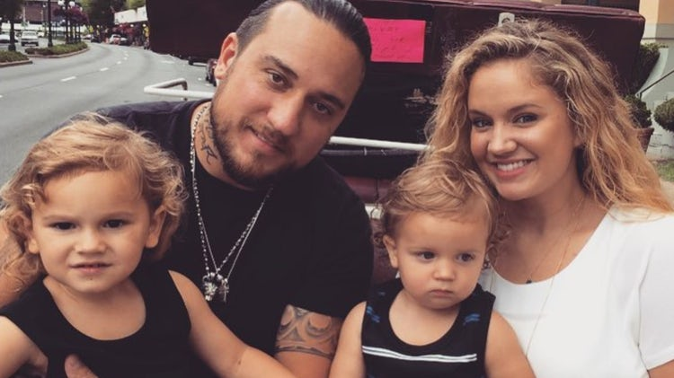

**Tiffany and Family**

However Tiffany’s marriage to Capaci has created a division among her fans, some criticizing her for moving on so quickly after the sudden and tragic death of her first husband. She replied on Instagram as follows: "This. This is love. That all-encompassing, enduring, accepting, near perfect love. The kind that trumps my need to snap back at people who have the audacity to comment on my Instagram about whether I loved my first husband or not. But let me take a moment to explain something to you. There is no timeline for grief or for when God moves in your life in undeniable ways. There are a lot of people who think it isn't good to be transparent on social media but I say forget that. I'm going to be open and honest because God wants me to. It's part of my testimony and it needs to be said,"

"So many emotions flooded my heart as I walked down those balcony steps [during the wedding ceremony] to the arms of my gift from God. I thought of Chris watching us and knowing he would have loved the choice I made, for me and for the boys. I thought of Chris's amazing parents sitting front row and how much of a blessing they have been and will forever be in our lives. How happy they are for the boys and I and how much they already love Josiah. I am so completely humbled by the love I receive from this man."

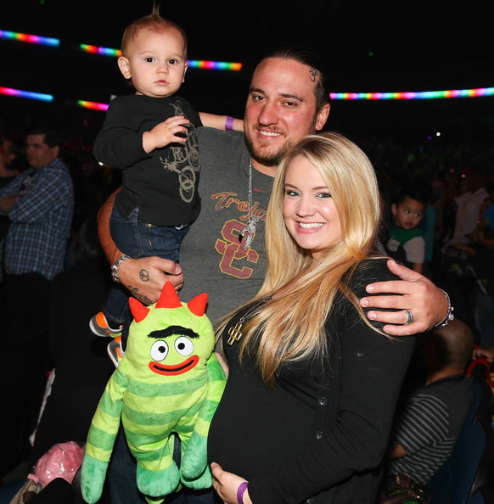

**Tiffany with a Pregnancy Bump**

Not satisfied with her explanation, some commenters made an issue with her choice of words when she said "Looking back now I think God saw that if I went too long without love that it would become increasingly difficult for me to submit to the authority of a husband after being set in my own ways."

Come on, let’s be realistic. This is a young, beautiful and talented lady that must get over the tragedies in her life move on.